

UNDERGRADUATE PROJECT PROPOSAL

|  |  |
| --- | --- |
| **Project Title:** | **Ensemble learning for the classification of Alzheimer disease.** |
| **Surname:** | **Liu** |
| **First Name:** | **Yue** |
| **Student Number:** | **201918020206** |
| **Supervisor Name:** | **Grace U. Nneji** |
| **Module Code:** | **CHC 6096** |
| **Module Name:** | **Project** |
| **Date Submitted:** | **6/11/2022** |

**Table of Contents**

1 Introduction 3

1.1 Background 3

1.2 Aim 3

1.3 Objectives 3

1.4 Project Overview 3

1.4.1 Scope 3

1.4.2 Audience 4

2 Background Review 4

2.1 Brief Summary of Some Related Works 4

3 Methodology 5

3.1 Approach 5

3.2 Technology 6

3.3 Version management plan 7

4 Project Management 7

4.1 Activities 7

4.2 Schedule 8

4.3 Data management plan 8

4.4 Deliverables 8

5 References 9

# Introduction

## Background

Alzheimer's disease (AD) involves the part of the brain that controls thought, memory and language, and is a progressive neurodegenerative disease with an insidious onset, the most common type of dementia with no known cause [1]. The majority of people with Alzheimer's disease are elderly. With the global ageing process, the number of people with Alzheimer's disease is likely to grow by over 100 million worldwide. At the same time, the cost of treatment will increase significantly and there is no cure for Alzheimer's disease, which could bring a certain degree of economy pressure to the world. The diagnosis of Alzheimer's disease is therefore one of the breakthroughs in solving this problem using Magnetic resonance imaging (MRI) [2].

## Aim

The project aims to take advantage of ensemble model for the efficient classification of Alzheimer disease, so as to take early measures to reduce mortality and reduce cost of medical resources.

## Objectives

1. Get to know what ensemble learning is.
2. Have a brief understanding about how to realize the medical image classification with the use of ensemble learning.
3. Explain more about the classification of Alzheimer disease with the use of ensemble learning.
4. Realize and evaluate about the model using different performance metrics such as accuracy, sensitivity, specificity, recall, precision, F1-score, ROC curve.
5. Model tweaking and fitting.
6. Final presentation of this project to the targeted audience.

## Project Overview

### Scope

It is well known that Convolutional Neural Networks (CNN)'s fast feature extraction capability makes its pattern recognition in image data analysis very effective. In addition, it has high accuracy in image classification, such as medical imaging [3]. But CNN model application could face one or more challenges which could be overfitting, be underfitting, the gradient disappears, etc. Thus, the purpose of this project is to take the merit of single channel CNN models and concatenate them for a robust performance which is refer to as Embedded learning for the classification of Alzheimer disease.

The significant of this study include:

* To help patients find health problems in time
* For researchers to carry out effective study for the diagnosis and treatment of the disease
* For medical purpose
* To reduce mortality rate
* To help reduce medical practitioner time and resources.

### Audience

1. Patients with Alzheimer's disease.
2. Physicians.
3. Hospital.

# Background Review

## Brief Summary of Some Related Works

Deep neural network has been utilized for analyzing and predicting medical images for physician and radiologists during diagnostics decision.

Fulton et al employed a ResNet model in diagnosing three classes and achieved 98.99% [4].

Maqsood et al proposed a transfer learning and fine-tuned AlexNet and achieved an accuracy of 92.85% for multi-class of the OASIS dataset [5].

Alanazi et al compared the hybrid algorithm between machine learning and deep learning in deep learning, and found that the accuracy, sensitivity, specificity and AUC values of the AlexNet+SVM model were 94.8%, 93%, 97.75% and 99.7% respectively, which was better [6].

In Lu et al’s research, when the number of iterations reaches 200, the accuracy of VGG 16 converges to 93% on the training set, and the accuracy of MobileNet converges to 98%, proving that the MobileNet network model is superior to the VGG 16 network model in terms of AD MRI image classification [7].

Plocharski et al developed an algorithm to calculate the inner surface of the groove for feature extraction, and based on this, proposed a model to distinguish AD patients from ordinary people, the accuracy, sensitivity and specificity of the model were 87.9%, 90% and 86.7% [8].

Elakkiya et al used the DEMNET (Dementia Network) model based on CNN to detect the four different stages of AD, and used the SMOTE method for data enhancement. The results of the model reached 95.23% of the test accuracy [9].

Rehman et al proposed hybrid classical quantum network for automatic detection of AD and ResnNet34 for feature extraction, achieving the highest test accuracy of 97.2% [10].

Table 1: Summarize the related work for Alzheimer disease classification.

|  |  |  |
| --- | --- | --- |
| Authors | Proposed Model/Technique | Performance Metrics |
| Fulton et al. [4] | ResNet50 model | Accuracy = 98.99% |
| Maqsood et al [5] | Fine-tuned AlexNet | Accuracy = 92.85% |
| Alanazi et al [6] | AlexNet+SVM hybrid models  ResNet-50+SVM hybrid models | Accuracy = 94.8%  Accuracy = 93.3% |
| Lu et al [7] | MobileNet | Accuracy = 98% |
| Plocharski et al [8] | Model for extracting medical features using a medical superficial sulcal pattern | Accuracy = 87.9%  Sensitivity = 90%  Specificity = 86.7% |
| Elakkiya et al [9] | DEMentia NETwork | Accuracy = 95.23% |
| Rehman et al [10] | The proposed hybrid classical quantum network /ResnNet34 | Accuracy = 97.2% |

# Methodology

## Approach

* Models: ResNet + AlexNet + MobileNet

The residual network(ResNet) is constructed from Residual Building Blocks, it does not increase the complexity of the network while increasing the depth of the network, and the effect is far better than other networks such as VGG and Google Net. With the increase of the number of floors, this advantage becomes more and more obvious. The quick connection of ResNet makes the network easier to optimize. The internal residual block uses a skip connection, which alleviates the problem of gradient disappearance caused by increasing depth in the deep neural network. AlexNet has an eight layer structure. The first five layers are convolutional neural networks, and the sixth to eighth layers are traditional neural networks. It uses the ReLU activation function to prevent the gradient from disappearing and the Dropout to prevent over fitting and it uses all to use the maximum pooling layer.

The MobileNet structure uses depthwith separable convolution to replace the standard convolution operation. Each layer is followed by a batchnorm and a ReLU nonlinear layer, which has 28 layers in total. MobileNet can not only reduce the computational complexity of the model, but also greatly reduce the size of the model.

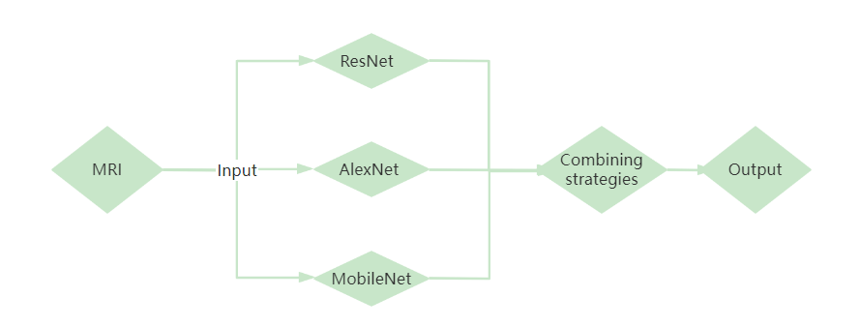

Figure 1 Structure of the model

* Dataset

There are 33984 cross-sectional MRI images of the brain with Alzheimer's disease in the data set of this project, including 8960 MRI images of mild dementia, 6464 MRI images of moderate dementia, 9600 MRI images of non-dementia, 8960 MRI images of very mild dementia, training set, verification set, and test set, with a distribution ratio of 6:2:2.

## Technology

Framework: PyTorch

IDE: Pycharm

Language: Python

Libraries: Scikit learn, Pandas, OpenCV, Scipy, Numpy

Central processing Unit (CPU): Intel(R) Core (TM) i7-9750H CPU @ 2.60GHz 2.59 GHz

Graphic Processing Unit (GPU): NVIDIA GeForce GTX 1650

## Version management plan

Use GitHub to make the version management of the project.

# Project Management

## Activities

1. Get to know what is ensemble learning.
   1. Search online and communicate with supervisor.
   2. Understand the ensemble learning.
   3. Make notes and write down own understanding.
2. Have a brief understanding about how to realize the medical image classification with the use of ensemble learning.
   1. Search online and communicate with supervisor.
   2. Make notes and write down own understanding.
3. Explain more about the classification of Alzheimer disease with the use of ensemble learning.
   1. Understand and select the appropriate model and understand the ensemble model.
   2. Understand and select the appropriate ensemble learning algorithm.
4. Learn and try to achieve.
   1. While learning the code, try to implement the selected model and merge.
   2. Preprocessing data sets
   3. Training model after data expansion.
   4. Evaluate the results.
5. Get results that can be displayed.
   1. Demonstrate the results.

## Schedule

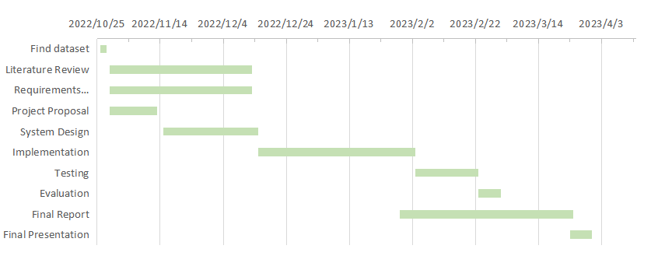

Figure 2 Gantt Diagram

## Data management plan

Use cloud folders to store data

* weekly project logs: progress, draft, next steps, supervisor comments, requirements or user stories.
* Project materials: sprint plans/reviews, testing documentation, literature etc.
* Reports: proposal, interim, final.

## Deliverables

* Weekly report
* The project proposal
* Image classification and diagnosis system of Alzheimer's disease (Codes)
* Project presentation (PPT)
* Final report

# References

1. An, N., Ding, H., Yang, J., Au, R., & Ang, T. F. A. (2020). Deep ensemble learning for Alzheimer's disease classification. Journal of Biomedical Informatics, 105, 103411. https://doi.org/10.1016/j.jbi.2020.103411
2. Bi, X., Liu, W., Liu, H., & Shang, Q. (2021). Artificial Intelligence-based MRI Images for Brain in Prediction of Alzheimer’s Disease. Journal of Healthcare Engineering, 2021, 1–7. https://doi.org/10.1155/2021/8198552
3. Wang, H., Shen, Y., Wang, S., Xiao, T., Deng, L., Wang, X., & Zhao, X. (2019). Ensemble of 3D densely connected convolutional network for diagnosis of mild cognitive impairment and Alzheimer’s disease. Neurocomputing, 333, 145–156. https://doi.org/10.1016/j.neucom.2018.12.018
4. Fulton, L., Dolezel, D., Harrop, J., Yan, Y., & Fulton, C. (2019). Classification of Alzheimer’s Disease with and without Imagery Using Gradient Boosted Machines and ResNet-50. Brain Sciences, 9(9), 212. https://doi.org/10.3390/brainsci9090212
5. Maqsood, M., Nazir, F., Khan, U., Aadil, F., Jamal, H., Mehmood, I., & Song, O. (2019). Transfer Learning Assisted Classification and Detection of Alzheimer’s Disease Stages Using 3D MRI Scans. Sensors, 19(11), 2645. https://doi.org/10.3390/s19112645
6. Mohammed, B. A., Senan, E. M., Rassem, T. H., Makbol, N. M., Alanazi, A. A., Al-Mekhlafi, Z. G., Almurayziq, T. S., & Ghaleb, F. A. (2021). Multi-Method Analysis of Medical Records and MRI Images for Early Diagnosis of Dementia and Alzheimer’s Disease Based on Deep Learning and Hybrid Methods. Electronics, 10(22), 2860. https://doi.org/10.3390/electronics10222860
7. Lu, X., Wu, H., & Zeng, Y. (2019). Classification of Alzheimer’s disease in MobileNet. Journal of Physics: Conference Series, 1345(4), 042012. https://doi.org/10.1088/1742-6596/1345/4/042012
8. Plocharski, M., & Østergaard, L. R. (2016). Extraction of sulcal medial surface and classification of Alzheimer’s disease using sulcal features. Computer Methods and Programs in Biomedicine, 133, 35–44. https://doi.org/10.1016/j.cmpb.2016.05.009
9. Murugan, S., Venkatesan, C., Sumithra, M. G., Gao, X.-Z., Elakkiya, B., Akila, M., & Manoharan, S. (2021). DEMNET: A Deep Learning Model for Early Diagnosis of Alzheimer Diseases and Dementia From MR Images. IEEE Access, 9, 90319–90329. https://doi.org/10.1109/ACCESS.2021.3090474
10. Shahwar, T., Zafar, J., Almogren, A., Zafar, H., Rehman, A. U., Shafiq, M., & Hamam, H. (2022). Automated Detection of Alzheimer’s via Hybrid Classical Quantum Neural Networks. Electronics, 11(5), 721. https://doi.org/10.3390/electronics11050721